The Health of Disability Support Pension and Newstart Allowance Recipients

ANALYSIS OF NATIONAL HEALTH SURVEY DATA
Professor Alex Collie, Mr Luke Sheehan, Dr Ashley Mcallister

September 2019

Contents
Study Highlights 6
Executive Summary 7
Introduction 11
Study Objectives 13
Methodology 13
National Health Survey 13
Study Groups 14
Self-Assessed Health 14
Health Conditions 14
Health Service Use 15
Medication & Supplement Use 15
Statistical Analyses 16
Results 18
Characteristics of Study Groups 18
Self-Assessed Health 21
Health Conditions 22
Health Service Use 30
Medication & Supplement Use 37
Strengths & Limitations 42
Summary & Conclusions 43
References 46
Appendix 48

Figures
Figure 1. Age and sex adjusted risk ratios for DSP and NSA recipients
rating their health in each category 22
Figure 2. Age and sex adjusted risk ratios for DSP recipients reporting at
least one condition in each ICD-10 category 24
Figure 3. Age and sex adjusted risk ratios for NSA recipients reporting at
least one condition in each ICD-10 category 25
Figure 4. The 20 ICD-10 conditions with the largest adjusted risk ratios
for prevalence in DSP recipients 26
Figure 5. The 20 ICD-10 conditions with the largest adjusted risk ratios
for prevalence in NSA recipients 27
Figure 6. Age and sex adjusted risk ratios for reporting multiple ICD-10
conditions in DSP and NSA recipients 28
Figure 7. Age and sex adjusted risk ratios for having visited a health
professional at least once in past 12 months for DSP recipients 32
Figure 8. Age and sex adjusted risk ratios for having visited a health
professional at least once in past 12 months for NSA recipients 33
Figure 9. Age and sex adjusted risk ratios for having used a particular
health service at least once in the past 12 months in DSP and NSA recipients 34
Figure 10. Age and sex adjusted incidence rate ratios for the frequency of visits to
a health professional or hospital in the past 12 months for DSP and NSA recipients 37
Figure 11. Age and sex adjusted risk ratios for having taken at least one medication
or supplement in the previous two weeks in DSP and NSA recipients 38
Figure 12. Age and sex adjusted incidence rate ratios for the number of different medications or supplements taken in the past two weeks for DSP and NSA recipients 39
Figure 13. Age and sex adjusted risk ratios for having used a medication
from an ATC category at least once in the past 2 weeks for DSP recipients 40
Figure 14. Age and sex adjusted risk ratios for having used a medication from
an ATC category at least once in the past 2 weeks for NSA recipients 41

Tables
Table 1. Characteristics of Wage Earners, Disability Support Pension
and Newstart Allowance groups 19
Table 2. Number and percentage of individuals who assessed their health to
be excellent, very good, good, fair or poor. 21
Table 3. Number and percentage of survey respondents with at least
one condition in each ICD-10 category, by study group 23
Table 4. Age and sex adjusted risk ratios comparing the top 10 reported
ICD-10 conditions in wage earners to DSP and NSA recipients 29
Table 5. Number and percentage of individuals in each group who visited
a particular health professional in the previous 12 months 30
Table 6. Number and percentage of individuals in each group who visited
a hospital or health centre in the previous 12 months 33
Table 7. Number and percentage of individuals in each group who visited
a particular health professional or health centre by frequency of visits 35
Table 8. Number and percentage of individuals in each group who took a
medication or supplement in the previous 2 weeks 37
Table 9. Number and percentage of individuals in each group taking none,
one or multiple medicines or supplements in the previous 2 weeks 39
Table 10. Abbreviations 48

This research report was prepared by Professor Alex Collie and Mr Luke Sheehan of the Insurance Work and Health Group, School of Public Health and Preventive Medicine, Monash University, Melbourne, Australia; and Dr Ashley McAllister of the Department of Public Health Sciences, Karolinksa Institute, Sweden.
For further information regarding this report please contact Professor Alex Collie (alex.collie@monash.edu or +61 3 9903 0525) or visit the study website www.dspstudy.com
This report may be cited as: Collie A, Sheehan L and McAllister A. The Health of Disability Support Pension and Newstart Allowance Recipients: Analysis of National Health Survey Data. Insurance Work and Health Group, School of Public Health and Preventive Medicine, Monash University (2019).
ACKNOWLEDGMENTS
This report contains findings based on Australian Bureau of Statistics data. Permission was obtained from the Australian Bureau of Statistics (ABS) to access the basic confidentialised unit record file (CURF) of the National Health Survey 2014—15 to enable data analysis.
The study was supported by an establishment grant provided by Monash University Faculty of Medicine Nursing and Health Sciences to Professor Collie. The authors gratefully acknowledge input on drafts of the report from staff of the Australian Federation of Disability Organisations, the National Social Security Rights Network and National Disability Services. The authors also acknowledge the support of Ms Dianne Beck in data management.
The views expressed in this report are those of the authors and do not necessarily reflect the views of funders or data providers. Information provided in this document can only assist an individual or organisation in a general way. Monash University is not engaged in rendering specific professional advice and Monash University accepts no liability arising from the use of, or reliance on, the material contained in this document. Before relying on the material, users should carefully make their own assessment as to its accuracy, currency, completeness and relevance for their purposes, and should obtain any appropriate professional advice relevant to their particular circumstances.

Study Highlights

This study analysed self-reported health and health service use data from 638 Disability Support Pension (DSP) recipients, 442 Newstart Allowance (NSA) recipients and 8440 wage earners who completed the 2014/15 National Health Survey.
1
2
38% of DSP recipients rated their health as good, very good or excellent, compared with 67% of NSA recipients and 91% of wage earners.
3
Despite 16% of DSP recipients in this study reporting psychological disability as their main disability type, 69% reported experiencing a mental or behavioural problem. People receiving the DSP reported a much higher prevalence of mood disorders, anxiety disorders, depression, obsessive compulsive disorder, alcohol and drug problems, post-traumatic stress disorder and problems of psychological development than wage earners.
4
The same pattern was observed among NSA recipients, where 8% reported psychological disability as their main disability, yet 48% reported experiencing a mental or behavioural problem.
5
People receiving the DSP and the NSA were more likely than wage earners to report health problems across a range of other disease categories. Both DSP and NSA groups were at greater risk of multi- morbidity (presence of multiple health conditions) than wage earners.
6
The rate of health service use was much higher in DSP recipients than wage earners. For example, more than two in every five (42.6%) DSP recipients visited a General Practitioner more than 10 times in the previous 12 months, compared to less than 5% of wage earners and 19% of NSA recipients.
7
More than one quarter (26%) of DSP recipients reported being admitted as a hospital inpatient in the previous 12 months and nearly one-quarter (23%) reported at least one visit to an emergency department. DSP recipients were at 2 to 3 times the risk of visiting a hospital than wage earners, while NSA recipients were at 1.5 to
2 times increased risk compared with wage earners.

Executive Summary
More than 1.4 million Australians receive the Disability Support Pension (DSP) or the Newstart Allowance (NSA). The annual cost to government of benefit payments alone to these two groups exceeds $27 billion. Global evidence shows that people receiving such social assistance benefits have poorer health on average than other working age people in paid employment. There is also evidence that changes in benefit scheme design and procedures can contribute to changes in health. There have been many changes to process and to policy in the Australian benefit system, administered by Centrelink, over the past decade. There are also very few recent studies focused on the health status and health service use of Australians receiving the DSP or the NSA.
Using data from the 2014/15 National Health Survey, this study described and compared the self-reported health conditions, health service use and medicines use in three groups of Australians: (a) People receiving the DSP;
(b) People receiving the NSA; and (c) People whose primary income sources was from wages (“wage earners”).

Self-Assessed Health
Participants were asked to rate their health today on a scale from 1 (excellent) to 5 (poor). The vast majority of wage earners rated their health as good,
very good or excellent with only 8.7% considering their health to be poor or fair. In contrast, more than three in every five DSP recipients rated their health as poor or fair (61.6%) as did one third of NSA recipients (33.3%).
People receiving the DSP were at 18.3 times more likely to rate their health as poor (the lowest category) than wage earners and four times more likely to rate their health as fair (the second lowest category). NSA recipients were 6.8 times more likely to rate their health as poor and 3.1 times more likely to rate their health as fair when compared to wage earners.

Health Conditions
Specific health conditions were grouped together using the categories of the International Statistical Classification of Diseases and Related Disorders version 10 (ICD-10). DSP recipients had significantly higher risk of reporting health conditions than wage earners across most ICD-10 disease categories. NSA recipients had significantly higher risk of reporting health conditions than wage earners in half of the disease categories.
The greatest differences in self-reported prevalence between DSP recipients and wage earners were in the mental and behavioural disorder category.
People receiving the DSP reported a much higher prevalence of mood disorders, anxiety disorders, depression, obsessive compulsive disorder, alcohol and drug problems, post-traumatic stress disorder and problems of psychological development.

People in the DSP group had at least 4 times, and up to 50 times, the relative risk of reporting each of these specific conditions than people in the wage earners group, reflecting very large differences in risk of these health conditions between the groups. A similar pattern was observed in NSA recipients compared with wage earners, although the magnitude of the differences between groups were smaller.
Both DSP and NSA recipients were significantly more likely to report having five or more conditions than wage earners, and less likely to report having fewer than five conditions, demonstrating the complex multi-morbidity in people receiving unemployment and disability support benefits. It is important to note that the health conditions reported are self-reported by participants – they are not necessarily related to the criteria used to determine eligibility for DSP or NSA benefit payments.

Consultations with Health Professionals
DSP recipients were significantly more likely than wage earners to have accessed a broad array of health services in the past 12 months, including services provided by social workers, psychologists, medical specialists, counsellors, nurses, pharmacists, diabetes educators and occupational therapists. People receiving the DSP were also significantly less likely to have visited dentists, chiropractors and osteopaths than wage earners.
People receiving the DSP also visited health professionals more often. For example, more than two in every five (42.6%) DSP recipients visited a
General Practitioner more than 10 times in the previous 12 months, compared to less than 5% of wage earners and 19% of NSA recipients.
Newstart recipients were significantly more likely than wage earners to have accessed health services provided by social workers, psychologists, counsellors, nurses, and chemists, and were less likely than wage earners to have visited a dentist, a chiropractor, an osteopath, or a physiotherapist in the preceding 12 months.

Hospitalisation
The prevalence and frequency of hospitalization varied significantly between groups. More than one quarter (25.7%) of DSP recipients reported being admitted as a hospital inpatient in the previous 12 months and nearly one- quarter (23.3%) reported at least one visit to an emergency department. DSP recipients were at 2 to 3 times the risk of visiting a hospital than wage earners, while NSA recipients were at 1.5 to 2 times increased risk than wage earners.
People receiving DSP benefits were significantly more likely to have had 2 or more hospital admissions, 2 or more visits to an emergency department and 2 or more visits to an outpatient or day clinic in the preceding 12 months than
wage earners. A similar pattern was observed in NSA recipients compared with wage earners.

Medication & Supplement Use
People receiving the DSP were also more likely to use medications than wage earners. Medications were categorized using the international Anatomical Therapeutic Chemical (ATC) Classification system. DSP recipients had a significantly greater risk of having used a medication in the previous two weeks in 11 of 12 different ATC categories, when compared with wage earners.
DSP recipients also reported a significantly higher rate of using multiple medications than wage earners (polypharmacy).
NSA recipients had a greater risk of having used a medication in the previous two weeks in 4 of 12 different ATC medicine categories when compared with wage earners. The largest increase in risk was for nervous system, musculoskeletal, and alimentary tract and metabolism medications.
People receiving the NSA were also more likely to use multiple medications than wage earners, though this effect was less pronounced than for DSP recipients. The rate of supplement use in reference to wage earners was significantly lower in both DSP recipients and NSA recipients.

Conclusions & Implications
This study found that people receiving DSP benefits report a much greater rate of ill health than wage earners across a range of disease categories, are more likely to report having multiple health conditions, are more likely to be hospitalised, are heavy users of healthcare services and have higher self- reported rates of medicine use and polypharmacy compared to wage earners.
Similar to the DSP group, Australians receiving the NSA report an increased prevalence of disease in multiple categories, have a higher rate of multi- morbidity, are more likely to use some health services and be hospitalised, and have a higher rate of multiple episodes of health service use than wage earners. While the magnitude of these effects are not as large as those observed for DSP recipients, our findings confirm a significantly increased burden of ill health in Australian NSA recipients compared with employed people of working age.
For both DSP and NSA recipients, the largest differences from wage earners are in the areas of mental and behavioural health.
Poor health and disability are substantial barriers to finding and maintaining employment. Actions that promote the health of DSP and NSA recipients will support improvements in the ability of people receiving these benefits to find jobs and keep them. There are multiple opportunities for government to take actions that improve the health of people receiving these benefits.
Health can be improved by delivering tailored health services. For example, it may be feasible to identify the individual health needs of DSP and NSA
recipients at the point of entry to the welfare system, and then deliver targeted health services that address those needs. Improving access to health services, including those that incur significant ‘out of pocket’ costs such as physical therapy and dentistry and are less accessible for benefit recipients, may support improvements in health. Identifying people with particularly complex or acute health needs, or those at greater risk of hospitalization, may enable intervention to prevent health shocks.

Health can be improved by addressing the social determinants of health. These are the conditions in which we are born, grow, work, live and age.
They include things such as access to housing and nutrition, support services, social inclusion, education and training. Poverty and financial distress are linked with poor health and reduced ability to participate in employment.
Actions that reduce the rate of poverty and serious financial stress amongst DSP and NSA recipients are thus likely to have a net positive impact
on health.
Health, and particularly mental health, can also be improved by reducing the burden of engaging with government. The psychological costs of applying for benefits and complying with bureaucratic processes can be substantial.
People with cognitive, intellectual or psychological conditions and those with less education, smaller support networks or other vulnerabilities are more likely to be adversely affected. Actions such as simplifying benefit application processes or funding services that can support people with disabilities to engage with Centrelink are likely to reduce the potentially adverse psychological impact of engaging with the welfare system.

Introduction
The Disability Support Pension (DSP) and the Newstart Allowance (NSA) are the two major Commonwealth social assistance programs for people of working age. The DSP is designed to provide financial support to people with permanent physical, intellectual or psychiatric impairments that prevent them from engaging in employment. The NSA provides financial support to people who are unemployed and are looking for work. The benefits provided under the two programs differ substantially. The common fortnightly payment rate for a single person residing in Australia and receiving the DSP is $926.20
(as at 20 March 2019). In contrast, the common fortnightly rate for a single person without children receiving the NSA is much lower at $555.70, excluding any additional supplements or allowances. Most people receiving the NSA also have obligations to participate in job seeking.[1]
Approximately 750,000 Australians receive the DSP.[2] The annual expenditure of DSP benefits approaches $17 billion, and 52% of recipients enrolled at June 2018 had received the DSP for more than 10 years.[3] The total lifetime cost of the DSP scheme to government has been estimated at $338 billion.[4] Approximately 715,000 Australians receive the NSA of whom 545,000 are considered long term recipients having received the Allowance for 12 months or more.[2, 5] Annual Commonwealth expenditure on income support for job seekers via the NSA and Youth Allowance is $11.1 billion.
Historically, the DSP has been one of the fastest growing government social assistance programs. Recent policy changes have slowed this growth. These include for example the 2012 “Job Readiness” reforms and the 2015 reform to the DSP medical assessment processes.[6, 7] The number of new DSP claims granted has fallen from 89,561 per annum in 2010—11 to 31,000 (2017/18) corresponding with a decline in the overall number of DSP recipients to 756,960 in 2017/18 from a high of 827,460 in 2011/12.[8] At the same time, the number of NSA recipients assessed as having a partial capacity to work due to illness or disability grew by 83% to 199,907. This growth rate is nearly 3.5 times faster than the growth in the total number of NSA recipients over the same period (26%). These figures demonstrate the interdependency between the DSP and NSA programs, with policy changes in one program affecting
the other.

The relationship between receiving social assistance benefits and poor health is well established. Internationally, studies have shown that unemployment and benefit receipt is associated with higher mortality and morbidity.[9,10] Australian studies of the health status of benefit recipients have typically focused on the relationship between benefit receipt and mental health. For example, Butterworth and colleagues’ analysis of the 2007 National Mental Health Survey demonstrated that the prevalence of mental disorders was significantly higher among Australians receiving unemployment benefits, parenting payments and the DSP compared with non-recipients.[11]
A more recent analysis of longitudinal data from the Household Labour and Income Dynamics in Australia (HILDA) study demonstrated that the greatest decline in mental health occurred during the transition period to DSP payments for people with disabilities, and the transition to parenting payments for single parents.[12] There is also international evidence that restricting access to disability insurance benefits contributes to growth in the number of people with significant health concerns enrolled in unemployment benefit programs [13], and potentially exacerbates or increases the burden of ill health in this population. [13,14,15]
Despite the DSP and NSA being two of the largest sources of income support for people who are unemployed and have complex health conditions, most current studies are about specific groups (e.g., defined by their condition or disability) or focus on a specific health outcome (e.g., mental health).
There are also few studies that have focused on both groups, and little is known about the number and pattern of health conditions across these populations. The recent changes in the profile of both the DSP and NSA programs suggests a need to update knowledge of the health status of people receiving benefits under both programs.
Relatively little is known about the extent and patterns of health service use in people receiving disability benefits, despite this group having complex medical conditions and thus likely to be heavy users of health services. Effective health service delivery may support reductions in disability and improvements in the ability to participate in work. An enhanced understanding of health service use among Australian benefit recipients would therefore support the design and delivery of both social services and public health policy
and programs.

Study Objectives
The study aims to provide new information around the health status and health service use of DSP and NSA recipients. The study aims to provide information that can be used for effective health care and social policy planning and delivery in these vulnerable groups.
Specifically, in this report we aim to:
- Characterise the health conditions and health service use of DSP and NSA recipients; and
- Compare the health and health service use of DSP and NSA recipients to that of people earning wages or business income.

Methodology

NATIONAL HEALTH SURVEY
This data used in this report is from the 2014/15 edition of the National Health Survey (NHS).[16] This was the most recent NHS data available at the time the study was initiated and is the most recent NHS containing information on receipt of government benefits. The NHS is an Australia-wide health survey conducted by the Australian Bureau of Statistics (ABS). The survey collects a range of information about the health of Australians, including:
- the prevalence of long-term health conditions;
- health risk factors such as smoking, obesity, alcohol consumption, physical activity; and
- demographic and socioeconomic characteristics.
The survey was conducted in all states and territories and across urban, rural and remote areas of Australia (excluding very remote areas). Within each dwelling one adult (18 years and over) and one child (if applicable) were randomly selected for inclusion in the survey. The survey was conducted from July 2014 to June 2015, and included around 19,000 people in nearly 15,000 private dwellings. The NHS includes information on sources of income, including types of Centrelink (social security) benefits, and thus enables the selection of groups of survey respondents who are receiving the DSP and other social security benefits.
In some instances, adult respondents were unable to answer for themselves due to significant long-term illness or disability. In these cases, a person responsible for them was interviewed on their behalf, provided the interviewer was assured that this was acceptable to the selected person. Where possible, the respondent was still present during the interview.

STUDY GROUPS
Three groups were defined for the study. The inclusion and exclusion criteria for each group are as follows:

Group 1. Disability Support Pension recipients
Cases were selected for inclusion in the DSP group if survey respondents were aged 18 to 64 years at the time of the survey and reported that they were receiving a DSP benefit at the time of the survey.

Group 2. Newstart Allowance recipients
Cases were selected for inclusion in the NSA group if survey respondents were aged 18 to 64 years at the time of the survey and reported that they were receiving the NSA at the time of the survey.

Group 3. Wage Earners
Cases were selected for inclusion in the wage earners group if survey respondents were aged 18 to 64 years at the time of the survey and reported that they were receiving Wages, Business Income or Other Cash Income at the time of the survey. Cases were excluded from this group if they reported receiving any government support that was not the Family Tax Benefit as an income source.

SELF-ASSESSED HEALTH
Respondents were asked to rate their own health using a single item of the Short-Form 12 (SF-12) Health Survey version 2. The question is posed as “In general, would you say your health is...” and respondents are asked to rate their health on the following scale:

- Excellent
- Very Good
- Good

HEALTH CONDITIONS
- Fair
- Poor

Health conditions when reported by respondents were coded to a list of approximately 1000 conditions. This list covers the more common types of long-term conditions experienced in the Australian community. For the majority of conditions, interviewers were able to select the appropriate condition from either category responses for questions or from a trigram coder attached to ‘other’ response categories. Where the interviewer could not find the condition in the coder or the condition name was not known at the time of the interview, efforts were made to ensure that the description of each condition which was recorded at interview was as precise and informative as possible, to enable detailed, accurate and consistent coding of conditions at a later time. As some conditions are specifically identified in the questionnaire and others are not, response levels and accuracy of reporting between conditions may be affected. The output classification used by the ABS was based on mapping between the 1000 input code list and the 10th revision of the International Statistical Classification of Diseases and Related Health Problems (ICD-10).[17]

It is important to note that the health conditions reported are self-reported by participants – they are not necessarily related to the criteria used to determine eligibility for DSP and NSA benefit payments.

HEALTH SERVICE USE
Respondents were asked whether they had taken any of the following actions in the last 12 months (shown on a prompt card)
More than one response was allowed

- Consulted a GP
- Consulted a specialist
- Consulted a dentist
- Consulted other health professionals
- Admitted to hospital as an inpatient
- Visited an outpatient clinic
- Visited emergency/casualty
- Visited a day clinic

If they had consulted an 'other health professional' in the last 12 months, they were asked (excluding any time spent in hospital) which other health professional(s) they had consulted (shown on a prompt card):
More than one response was allowed

  - Aboriginal health worker
  - Accredited counsellor
  - Acupuncturist
  - Alcohol and drug worker
  - Audiologist/Audiometrist
  - Chemist/Pharmacist (for advice only)
  - Chiropodist/Podiatrist
  - Chiropractor
  - Diabetes educator
  - Dietitian/Nutritionist
  - Naturopath
  - Herbalist
- Hypnotherapist
- Nurse
- Occupational therapist
- Optician/Optometrist/Orthoptist
- Osteopath
- Physiotherapist/Hydrotherapist
- Psychologist
- Radiographer
- Social worker/Welfare officer
- Sonographer
- Speech therapist/Pathologist
- Other

Respondents who had consulted a GP, specialist or dentist, been admitted to hospital as an inpatient, visited an outpatient or day clinic, or visited emergency/casualty in the last 12 months were asked how many times they had done so during that period.

MEDICATION & SUPPLEMENT USE
Respondents were asked for the names or brands of all medications and dietary supplements (vitamins, minerals and natural or herbal supplements) they had taken in the last 2 weeks. Respondents were encouraged to have all of their medications and supplements in front of them during the interview to assist in reporting the information. Interviewers recorded the Australian Register of Therapeutic Goods Administration (TGA) identification number of each medication taken by the respondent. The therapeutic substances people reported were coded as either ‘medications’ or as ‘dietary supplements’.
Medications were coded based on their active ingredient(s) and their therapeutic application, to the World Health Organisation Anatomical Therapeutic Chemical (ATC) classification system.

STATISTICAL ANALYSES

Age and Sex Adjustment
Individuals of different ages and sexes have different health conditions and different approaches to their health care. To be sure that any differences seen between the groups is not due to differences in age and sex, all models used to calculate the risk ratios and incidence rate ratios took into account the age and sex of the individuals.

Risk Ratios
Risk ratios compare the risk of a particular event having occurred or not in two separate groups. In this report age and sex adjusted risk ratios were calculated to compare the risk of having a health condition, having used a health service or having used a medication between study groups. Risk ratios were calculated using log binomial generalised linear regression models.

Incidence Rate Ratios
Incidence rate ratios compare the frequency with which a particular event occurred in two separate groups. In this report age and sex adjusted incidence rate ratios were calculated to compare the number of health conditions, frequency of health service use, and number of medications used between groups. Incidence rate ratios were calculated using negative binomial regression models.

Interpreting Risk Ratios and Incidence Rate Ratios
When a risk ratio or incidence rate ratio is calculated, one group is the reference group (in this report the wage earners group) and has a value set at 1. The other group is the comparator group (in this report either the DSP or NSA) and can change in value.
If the risk or incidence rate ratio in the comparator group (DSP or NSA) is greater than 1, then this means that there is a greater risk or incidence rate than in the reference group of wage earners, e.g., a ratio of 2:1 indicates twice the risk or incidence in the comparator group compared with the reference group.
If the risk ratio or incidence rate ratio in the comparator group (DSP or NSA) is less than 1 then there is reduced risk or incidence rate than in the reference group of wage earners, e.g., a ratio of 0.5:1 indicates half the risk or incidence in the comparator group compared with the reference group.
A risk ratio or incidence rate ratio of 1 indicates that there is no difference between the two groups being compared i.e., the ratio is 1:1.

95% Confidence Intervals
When performing statistical analysis on a sample of people there is always some uncertainty that the value calculated in this sample will be the same as the value we would get if we were able to do the same calculation in the whole population. Because of this, in addition to the calculated risk ratio or incidence rate ratio, a 95% confidence interval is calculated. This presents a range in which we are 95% sure that the risk ratio or incidence rate ratio for the whole population will be. The bars around the calculated ratio on each figure represent this.
If the 95% confidence interval for a risk ratio or incidence rate ratio does not include 1 then we would consider this statistically significant evidence for a difference between the groups being compared (since a value of 1 indicates no difference between groups).
For example, a 95% confidence interval that ranges from 0.94—1.33 would not be considered to provide evidence of a statistical difference between groups as the 95% confidence interval includes values both above and below 1. In contrast, a 95% confidence interval that ranges from 1.14—1.33 would be considered to provide statistical evidence of a difference between groups as all values in the 95% confidence interval are greater than 1.
Confidence intervals vary in size depending on the amount of information available. If an outcome is common, we can be more certain about our calculation and the 95% confidence interval will be small. If the outcome is rare, we have less information, can be less sure about the calculated value, and so the 95% confidence interval will be larger.

Results

CHARACTERISTICS OF STUDY GROUPS
There were a total 11,296 working age adults surveyed in the 2014/15 edition of the NHS. This included a total of 638 DSP recipients, 442 NSA recipients and 8440 people who met our definition of wage earners. There were a further 1776 individuals of working age who participated in the survey but did not fit the criteria of any group and these people were excluded from
further analyses.
Table 1 shows the characteristics of those in each of the three study groups. There were very large differences in the age profiles between groups.
For example one in five wage earners were aged 55 to 64 years, whereas in the NSA group this was one in four, and in the DSP group nearly one in two. Females comprised 49%, 54%, and 57% of the wage earners, DSP and NSA groups, respectively.
Over half of DSP recipients and two in five NSA recipients had not completed high school, in comparison to 15% in the wage earners group.
Correspondingly, DSP and NSA recipients were much less likely to have tertiary qualifications. The socioeconomic status of DSP and NSA recipients also differed from wage earners with approximately three quarters classified in the lower half of the socioeconomic scale. Less than one in five DSP and NSA recipients had private health insurance, compared to two thirds of the wage earners group. DSP and NSA recipients were less likely to have consumed alcohol in the week preceding the survey.
Thirty percent of DSP recipients reported severe core activity limitation and 44% moderate/mild limitation. However, seventy-one DSP recipients (11%) did not report having a disability or long-term health condition. This may be explained by an unwillingness to disclose this information in the survey, or the survey respondents not perceiving themselves as disabled despite having health conditions. Just under three quarters of the wage earners reported no disability or long-term health condition. In the NSA group 47% reported no disability or long-term health condition, 24% reported a mild/moderate core activity limitation and 4% severe limitation.
Physical disability was the most common main disability type reported in all groups. In both the DSP and NSA group psychological disability was the second most common main disability type, followed by ‘other’ disabilities and then disability in sight, hearing and speech.

TABLE 1. CHARACTERISTICS OF WAGE EARNERS, DISABILITY SUPPORT PENSION AND NEWSTART
ALLOWANCE GROUPS
 | Wage Earners (Column %) | DSP Group (Column %) | NSA Group (Column %)
Total Number Included in Sample | 8440 (100%) | 638 (100%) | 442 (100%)
Age in Years
18 to 24 | 765 (9.1%) | 25 (3.9%) | 34 (7.7%)
25 to 34 | 1945 (23.0%) | 36 (5.6%) | 70 (15.8%)
35 to 44 | 2117 (25.1%) | 98 (15.4%) | 107 (24.2%)
45 to 54 | 1957 (23.2%) | 171 (26.8%) | 113 (25.6%)
55 to 64 | 1656 (19.6%) | 308 (48.3%) | 118 (26.7%)
Sex
Male | 4310 (51.1%) | 293 (45.9%) | 188 (42.5%)
Female | 4130 (48.9%) | 345 (54.1%) | 254 (57.5%)
Highest Level of Education
Less than Year 12 | 1232 (14.8%) | 331 (53.0%) | 172 (39.9%)
Year 12 | 1125 (13.5%) | 83 (13.3%) | 48 (11.1%)
Certificate or Diploma | 2902 (34.9%) | 166 (26.6%) | 160 (37.1%)
Bachelor Degree | 1948 (23.4%) | 37 (5.9%) | 36 (8.4%)
Postgraduate Degree | 1101 (13.3%) | 8 (1.3%) | 15 (3.5%)
Proficiency in Spoken English
Not well/Not at all | 114 (1.4%) | 14 (2.2%) | 25 (5.7%)
Well/Very well | 731 (8.7%) | 21 (3.3%) | 24 (5.4%)
Mainly speaks English at home | 7595 (90.0%) | 600 (94.5%) | 393 (88.9%)
Index of Relative Socio-economic Disadvantage
Lowest socioeconomic half | 3526 (41.8%) | 506 (79.3%) | 318 (71.9%)
Highest socioeconomic half | 4914 (58.2%) | 132 (20.7%) | 124 (28.1%)

TABLE 1. CHARACTERISTICS OF WAGE EARNERS, DISABILITY SUPPORT PENSION AND NEWSTART
ALLOWANCE GROUPS
 | Wage Earners (Column %) | DSP Group (Column %) | NSA Group (Column %)
Total Number Included in Sample | 8440 (100%) | 638 (100%) | 442 (100%)
Disability Status
No disability or long-term health condition | 6174 (73.2%) | 71 (11.1%) | 208 (47.1%)
No limitation or specific restriction | 1248 (14.8%) | 18 (2.8%) | 52 (11.8%)
Schooling/employment restriction only | 296 (3.5%) | 78 (12.2%) | 58 (13.1%)
Mild/moderate core activity limitation | 613 (7.3%) | 279 (43.7%) | 106 (24.0%)
Severe/profound core activity limitation | 109 (1.3%) | 192 (30.1%) | 18 (4.1%)
Main Disability Type
Sight, hearing, speech | 549 (6.5%) | 31 (4.9%) | 37 (8.4%)
Physical | 1281 (15.2%) | 299 (46.9%) | 129 (29.2%)
Intellectual | 53 (0.6%) | 25 (3.9%) | 5 (1.1%)
Psychological | 141 (1.7%) | 104 (16.3%) | 36 (8.1%)
Head injury, stroke or brain damage | 7 (0.1%) | 24 (3.8%) | 0 (0.0%)
Other | 235 (2.8%) | 84 (13.2%) | 27 (6.1%)
Not applicable | 6174 (73.2%) | 71 (11.1%) | 208 (47.1%)
Currently Covered by Private Health Insurance
With private health insurance | 5599 (66.5%) | 104 (16.3%) | 84 (19.1%)
Without private health insurance | 2819 (33.5%) | 534 (83.7%) | 356 (80.9%)
Alcohol Risk in Past Week
Has not consumed alcohol in past week | 2998 (35.7%) | 389 (61.8%) | 229 (52.3%)
Low risk | 4424 (52.6%) | 182 (28.9%) | 149 (34.0%)
Medium risk | 613 (7.3%) | 30 (4.8%) | 30 (6.8%)
High risk | 374 (4.4%) | 28 (4.5%) | 30 (6.8%)
Data is presented as Number (column percentage); DSP = Disability Support Pension; NSA = Newstart Allowance

SELF-ASSESSED HEALTH
Self-assessed health status is a commonly used measure of general or overall health. It can be a useful measure of average health status when applied in groups or populations. The number and percentage of people in each group who rated their health from 1 (excellent) to 5 (poor) is provided in Table 2.
Results indicate that:
- 91.3% of wage earners rate their health as good, very good or excellent, compared with 38.4% of DSP recipients and 66.7% of the NSA group.
- More than three in every five people receiving the DSP rated their health as poor or fair (61.6%)
- One third of NSA recipients rated their health as poor or fair (33.3%).

TABLE 2. NUMBER AND PERCENTAGE OF INDIVIDUALS WHO ASSESSED THEIR
HEALTH TO BE EXCELLENT, VERY GOOD, GOOD, FAIR OR POOR.
Self-Assessed Health | Wage Earners | DSP Group | NSA Group
Excellent | 1903 (22.5%) | 21 (3.3%) | 46 (10.4%)
Very Good | 3425 (40.6%) | 51 (8.0%) | 119 (26.9%)
Good | 2381 (28.2%) | 173 (27.1%) | 130 (29.4%)
Fair | 610 (7.2%) | 208 (32.6%) | 102 (23.1%)
Poor | 121 (1.4%) | 185 (29.0%) | 45 (10.2%)

The data in Table 2 is unadjusted. When adjusted for age and sex, the differences between groups become more apparent.
Figure 1 presents the age and sex adjusted risk ratios for the DSP and NSA groups compared to wage earners for each of the self-rated health categories. Results show that:
- DSP recipients are at 18.3 times the risk of assessing their own health as poor compared to wage earners and 4.1 times the risk of assessing their own health as fair.
- NSA recipients are at 6.8 times the risk of assessing their own health as poor compared to wage earners and 3.1 times the risk of assessing their own health as fair.
- Both the DSP and NSA groups are significantly less likely to assess their own health as very good or excellent than the wage earners group, with these effects more pronounced in the DSP group.

Figure 1. Age and sex adjusted risk ratios for DSP and NSA recipients rating their health in each category compared with wage earners
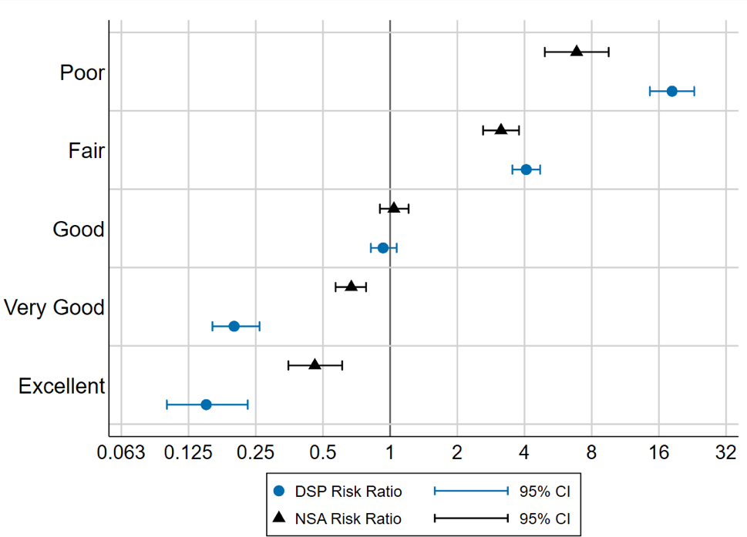

HEALTH CONDITIONS

Disease & Condition Categories
The ICD-10 is an international standard classification system for diseases and health problems that categorises specific diseases and conditions into 16 major categories. The number and proportion of each group with at least one condition in each ICD-10 category is shown in Table 3. Results include that:
- DSP recipients had the highest proportion of individuals with at least one condition across all 16 ICD-10 categories.
- Nearly three quarters (71.3%) of DSP recipients and almost half (48.2%) of NSA recipients reported having diseases of the musculoskeletal system.
- More than two thirds (69.1%) of DSP recipients and nearly half (48.6%) of NSA recipients reported having mental and behavioural problems.
- More than half (51.9%) of DSP recipients reported having circulatory system diseases.
- Diseases of the eye and adnexa were the most commonly reported conditions in all groups of participants.

TABLE 3. NUMBER AND PERCENTAGE OF SURVEY RESPONDENTS WITH AT LEAST ONE
CONDITION IN EACH ICD-10 CATEGORY, BY STUDY GROUP
ICD-10 Disease Category | Wage Earners | DSP Group | NSA Group
Diseases of eye and adnexa | 5307 (62.9%) | 525 (82.3%) | 301 (68.1%)
Diseases of the musculoskeletal system and connective tissue | 2942 (34.9%) | 455 (71.3%) | 213 (48.2%)
Mental and behavioural problems | 1772 (21.0%) | 441 (69.1%) | 215 (48.6%)
Diseases of circulatory system | 2202 (26.1%) | 331 (51.9%) | 162 (36.7%)
Diseases of respiratory system | 3376 (40.0%) | 329 (51.6%) | 186 (42.1%)
Endocrine, nutritional and metabolic diseases | 1629 (19.3%) | 265 (41.5%) | 117 (26.5%)
Symptoms, signs and conditions not elsewhere classified | 1356 (16.1%) | 209 (32.8%) | 85 (19.2%)
Diseases of ear and mastoid | 1043 (12.4%) | 174 (27.3%) | 86 (19.5%)
Diseases of nervous system | 767 (9.1%) | 146 (22.9%) | 62 (14.0%)
Diseases of the digestive system | 500 (5.9%) | 109 (17.1%) | 52 (11.8%)
Neoplasms | 725 (8.6%) | 95 (14.9%) | 34 (7.7%)
Diseases of genito-urinary system | 286 (3.4%) | 65 (10.2%) | 26 (5.9%)
Diseases of the skin and subcutaneous tissue | 416 (4.9%) | 48 (7.5%) | 22 (5.0%)
Diseases of blood and blood forming organs | 178 (2.1%) | 29 (4.5%) | 9 (2.0%)
Certain infectious and parasitic diseases | 57 (0.7%) | 14 (2.2%) | 2 (0.5%)
Congenital malformations, deformations and chromosomal abnormalities | 39 (0.5%) | 9 (1.4%) | 3 (0.7%)
No condition | 802 (9.5%) | 3 (0.5%) | 23 (5.2%)

The data in Table 3 is unadjusted. When adjusted for age and sex, the differences between groups in the rate of different conditions becomes more apparent.
Figure 2 presents age and sex adjusted risk ratios for the DSP group compared to the wage earners group.
These results indicate that:
- DSP recipients had significantly higher risk of reporting health conditions than
the wage earners group in all ICD-10 categories except diseases of eye and adnexa, and neoplasms.
- DSP recipients had three to four times the relative risk of mental and behavioural problems, infectious diseases and congenital conditions than wage earners.
- DSP recipients had two to three times the relative risk of nervous system, digestive system, genito-urinary system and blood diseases than wage earners.

Figure 2. Age and sex adjusted risk ratios for DSP recipients reporting at least one condition in each ICD-10 category compared to wage earners

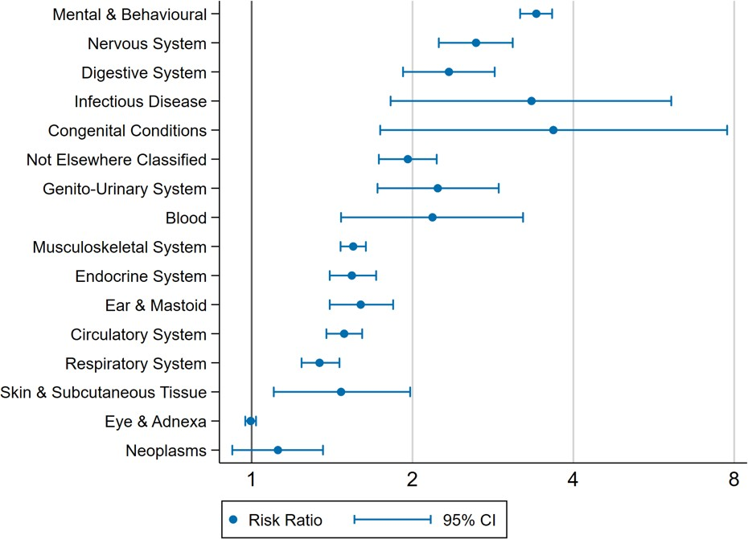

Figure 3 presents age and sex adjusted risk ratios for the NSA group compared to the wage earners group. These results indicate that:
- NSA recipients had significantly higher risk of reporting health conditions than the wage earners group in eight of the sixteen ICD-10 categories.
- NSA recipients had more than two times the relative risk of reporting mental and behavioural problems than wage earners.
- NSA recipients had significantly higher risk than wage earners of reporting digestive system, ear and mastoid, nervous system, musculoskeletal and connective tissue, circulatory system, endocrine, nutritional and metabolic, and genito-urinary system diseases.

Figure 3. Age and sex adjusted risk ratios for NSA recipients reporting at least one condition in each ICD-10 category compared to wage earners
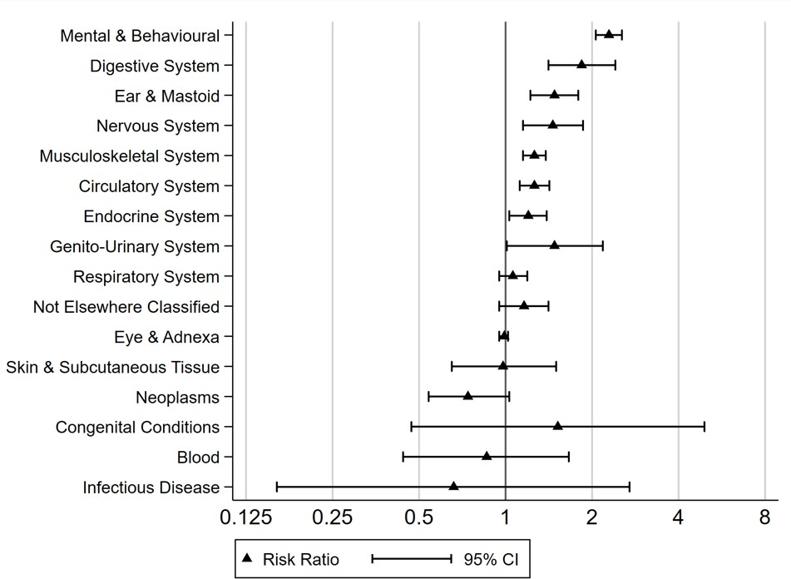

Specific Diseases & Conditions
In addition to broad categories of disease, we examined the specific conditions reported in the NHS by people in each of the three study groups.
Figure 4 presents the 20 conditions with the highest age and sex adjusted relative risk (RR) of being reported by the DSP group compared to the wage earners group.
These results indicate that:
- DSP recipients have a higher risk of reporting a number of psychological and mental health conditions and symptoms compared with wage earners. Thirteen of the 20 conditions with the highest RR were in the mental and behavioural disorder category and included mood disorders, anxiety disorders, depression, obsessive compulsive disorder, alcohol and drug problems, post-traumatic stress disorder, and problems of psychological development.
- The highest relative risk in DSP recipients were for ‘Other Mental and Behavioural Problems’, ‘Autism Spectrum Disorders’, and ‘Other Affective Mood Disorders’
- People in the DSP group had at least 4 times, and up to 50 times, the relative risk of reporting each of these specific conditions than people in the wage earners group, reflecting very large differences in risk of these conditions between the two groups.

Figure 4. The 20 ICD-10 conditions with the largest adjusted risk ratios for prevalence in DSP recipients compared with wage earners
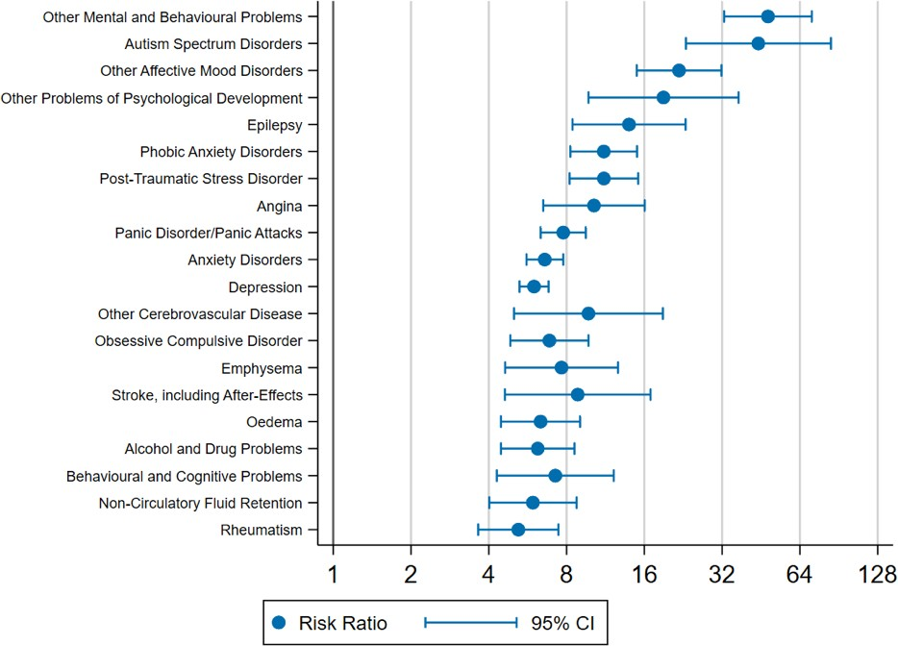

Figure 5 presents the 20 conditions with the highest age and sex adjusted relative risk (RR) of being reported by the NSA group compared to the wage earners group.
These results indicate that:
- In the NSA group the largest increases in risk were observed for ‘Emphysema’, ‘Other Problems of Psychological Development’, and ‘Other Mental and Behavioural Problems’.
- NSA recipients have a higher risk of reporting a number of psychological and mental health conditions and symptoms compared with wage earners. Twelve of the 20 conditions with the highest RR were in the mental and behavioural disorder category and included depression, post-traumatic stress disorder, anxiety disorders, obsessive compulsive disorders, alcohol and drug problems, affective mood disorders, and problems of psychological development.
- People in the NSA group had at least 2 times, and up to 6 times, the relative risk of reporting each of these 20 specific conditions than people in the wage earners group, reflecting large differences in risk of these conditions between the two groups.

Figure 5. The 20 ICD-10 conditions with the largest adjusted risk ratios for prevalence in NSA recipients compared with wage earners

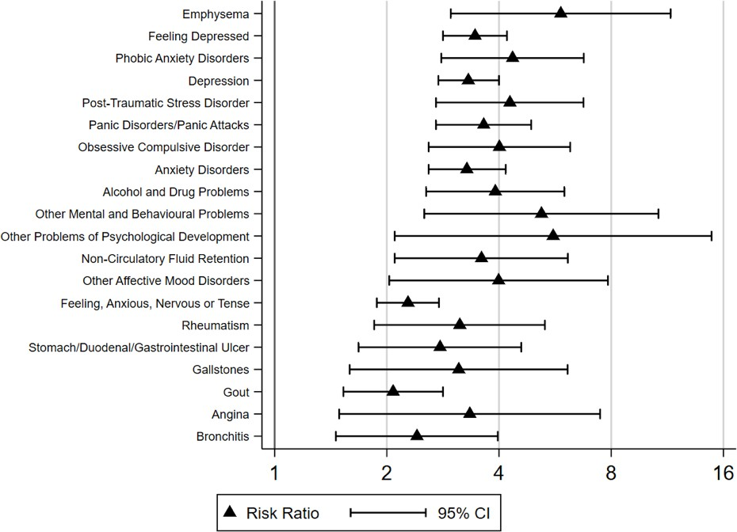

Multi-morbidity
We also sought to determine whether DSP and NSA recipients were more or less likely to report having multiple conditions than wage earners. To do this we first calculated for each individual how many specific conditions they reported and then categorised individuals into four sub-groups (1) 0 to 4 conditions; (2) 5 to 9 conditions; (3) 10 to 14 conditions; (4) 15 or more conditions.
Figure 6 presents the age and sex adjusted risk ratios for an individual in each of the DSP and NSA groups being in each of these groups, relative to the wage earners group.
These results show that:
- Both DSP and NSA recipients were significantly more likely to report having five or more conditions than wage earners.
- Both DSP and NSA recipients were significantly less likely to report having four or fewer conditions than wage earners.
- Those on the DSP had over 17 times the risk of reporting more than 15 conditions, while those on the NSA had over 5 times the risk of reporting 15 or more conditions, relative to wage earners.

Figure 6. Age and sex adjusted risk ratios for reporting multiple ICD-10 conditions in DSP and NSA recipients compared to wage earners
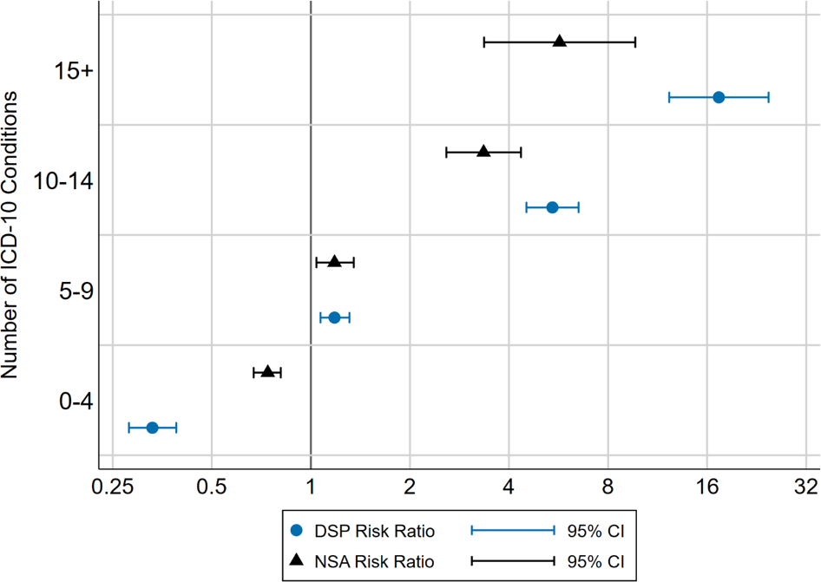

Most Common Conditions in Wage Earners
In a further effort to understand the differences between wage earners and DSP and NSA recipients, we calculated the top ten most commonly reported conditions in wage earners, and then determined the age and sex adjusted relative risk of reporting these conditions in the DSP and NSA groups compared to wage earners. This data is shown in Table 4.
This analysis demonstrates that:
- Long and short sightedness are the first and fourth most common conditions in wage earners. NSA recipients are at slightly greater risk of reporting long-sightedness and slightly lower risk of reporting short-sightedness.
- Five of the top ten most common conditions reported by wage earners relate to mental health or psychological symptoms. In all cases NSA and DSP recipients are at significantly greater risk of reporting these conditions than wage earners and the magnitude of the increased risk is substantial, ranging from 2.3 times increased risk of feeling anxious in NSA recipients to 7.8 times increased risk of panic disorders in
DSP recipients.

TABLE 4. AGE AND SEX ADJUSTED RISK RATIOS COMPARING THE TOP 10 REPORTED ICD-10 CONDITIONS IN WAGE EARNERS TO DSP AND NSA RECIPIENTS
Condition DSP Group NSA Group

 | RR | 95% CIs | p | RR | 95% CIs | p
Long sight/hyperopia | 1.04 | 0.97—1.13 | 0.28 | 1.10 | 1.00—1.21 | 0.05
Depression | 5.99 | 5.26 – 6.82 | < 0.001 | 3.31 | 2.75—4.00 | < 0.001
Asthma | 1.95 | 1.74 – 2.18 | < 0.001 | 1.12 | 0.94—1.33 | 0.21
Short sight/myopia | 0.97 | 0.87—1.09 | 0.61 | 0.81 | 0.69—0.94 | 0.01
Hypertensive disease | 1.60 | 1.42—1.81 | < 0.001 | 1.35 | 1.14—1.63 | 0.001
Feeling anxious, nervous or tense | 3.30 | 2.85—3.81 | < 0.001 | 2.28 | 1.88—2.76 | < 0.001
Arthritis—osteoarthritis | 2.12 | 1.85—2.43 | < 0.001 | 1.53 | 1.23—1.91 | < 0.001
Anxiety disorders | 6.59 | 5.60—7.77 | < 0.001 | 3.28 | 2.59—4.17 | < 0.001
Feeling depressed | 4.13 | 3.51—4.86 | < 0.001 | 3.45 | 2.83—4.20 | < 0.001
Panic disorders/panic attacks | 7.77 | 6.34—9.50 | < 0.001 | 3.64 | 2.71—4.88 | < 0.001
Note: Reference group for both analyses is wage earners; RR = risk ratio; CIs = Confidence Intervals; p = statistical significance where p < 0.05 indicates a statistically significant difference.

HEALTH SERVICE USE
Another way of understanding the burden of ill health among a population is to examine use of health services such as primary care, allied health, hospital visits and medicines. We used the data in the NHS to describe and compare health service use between DSP recipients, NSA recipients and wage earners.

Visits to a Health Professional
The NHS records self-reported visits to a health professional in the preceding 12 months. The number and percentage of each group reporting that they had visited the various health professional groups is presented in Table 5.

TABLE 5. NUMBER AND PERCENTAGE OF INDIVIDUALS IN EACH GROUP WHO VISITED A
PARTICULAR HEALTH PROFESSIONAL IN THE PREVIOUS 12 MONTHS
Health Professional | Wage Earners (N=8440) | DSP Group (N=638) | NSA Group (N=442)
General Practitioner | 7100 (84.2%) | 611 (95.8%) | 391 (88.5%)
Specialist | 2746 (32.5%) | 389 (61.0%) | 171 (38.7%)
Dentist | 4133 (49.0%) | 232 (36.4%) | 162 (36.7%)
Chemist (for advice only) | 761 (9.0%) | 151 (23.7%) | 56 (12.7%)
Psychologist | 420 (5.0%) | 120 (18.8%) | 55 (12.4%)
Other Health Professional | 427 (5.1%) | 87 (13.6%) | 33 (7.5%)
Nurse | 273 (3.2%) | 83 (13.0%) | 30 (6.8%)
Optician/Optometrist/Orthoptist | 566 (6.7%) | 82 (12.9%) | 19 (4.3%)
Physiotherapist/Hydrotherapist | 848 (10.1%) | 80 (12.5%) | 26 (5.9%)
Dietitian/Nutritionist | 181 (2.1%) | 68 (10.7%) | 14 (3.2%)
Radiographer | 380 (4.5%) | 66 (10.3%) | 31 (7.0%)
Social Worker/Welfare Officer | 49 (0.6%) | 52 (8.2%) | 20 (4.5%)
Podiatrist | 245 (2.9%) | 50 (7.8%) | 9 (2.0%)
Diabetes Educator | 81 (1.0%) | 44 (6.9%) | 7 (1.6%)
Counsellor | 147 (1.7%) | 42 (6.6%) | 22 (5.0%)
Occupational Therapist | 74 (0.9%) | 26 (4.1%) | 5 (1.1%)
Chiropractor | 514 (6.1%) | 20 (3.1%) | 14 (3.2%)
Audiologist/Audiometrist | 50 (0.6%) | 15 (2.4%) | 6 (1.4%)
Sonographer | 110 (1.3%) | 13 (2.0%) | 6 (1.4%)
Naturopath | 206 (2.4%) | 12 (1.9%) | 10 (2.3%)

TABLE 5. NUMBER AND PERCENTAGE OF INDIVIDUALS IN EACH GROUP WHO VISITED A
PARTICULAR HEALTH PROFESSIONAL IN THE PREVIOUS 12 MONTHS
Health Professional | Wage Earners (N=8440) | DSP Group (N=638) | NSA Group (N=442)
Acupuncturist | 190 (2.3%) | 10 (1.6%) | 5 (1.1%)
Osteopath | 150 (1.8%) | 6 (0.9%) | 4 (0.9%)
All data is presented as Number (percentage). Respondents may report more than one health professional and thus column percentages will exceed 100% when summed.

Results demonstrate that:
- People in all three groups were most likely to report visits to general practitioners, specialists and dentists. It is important to note that participants in the NHS were asked specifically about these three types of health provider, but this was not the case for the other health provider categories.
- A higher proportion of DSP recipients reported visits to all healthcare professionals with the exception of dentists, chiropractors, naturopaths, acupuncturists, and osteopaths.
- Despite the high prevalence of mental and behavioural problems reported by DSP recipients and reported in the prior section, only 18.8% reported having visited a psychologist in the past 12 months.
- The vast majority of people in all three groups reported visiting a general practitioner in the preceding 12 months, with the proportion slightly higher in DSP recipients compared with both NSA and wage earner groups.
- More than three in five (61.0%) DSP recipients reported visiting a specialist medical practitioner in the past twelve months compared with around one third of wage earners (32.5%) and slightly more than one third of NSA recipients (38.7%).
The data in Table 5 is unadjusted. When adjusted for age and sex, the differences between groups in the rate of health service use becomes more apparent. Figure 7 presents age and sex adjusted risk ratios (RRs) of having visited each of the 22 health professionals for the DSP group compared to the Wage Earners group.

These results indicate that:
- DSP recipients were significantly more likely than wage earners to have seen 15 of the 22 health professionals in the past 12 months and significantly less likely to have seen 3 of the 22 health professionals.
- The greatest difference between groups was observed for social worker/welfare officer where the DSP group were at more than 16 times greater risk of visiting a social worker in the past 12 months than wage earners.
- DSP recipients were at 4 or more times the risk of visiting a diabetes educator, psychologist, dietitian/nutritionist, nurse, occupational therapist, or counsellor than wage earners.
- DSP recipients were at significantly lower risk of visiting a dentist, a chiropractor, or an osteopath in the preceding 12 months than wage earners.

Figure 7. Age and sex adjusted risk ratios for having visited a health professional at least once in past 12 months for DSP recipients compared to wage earners
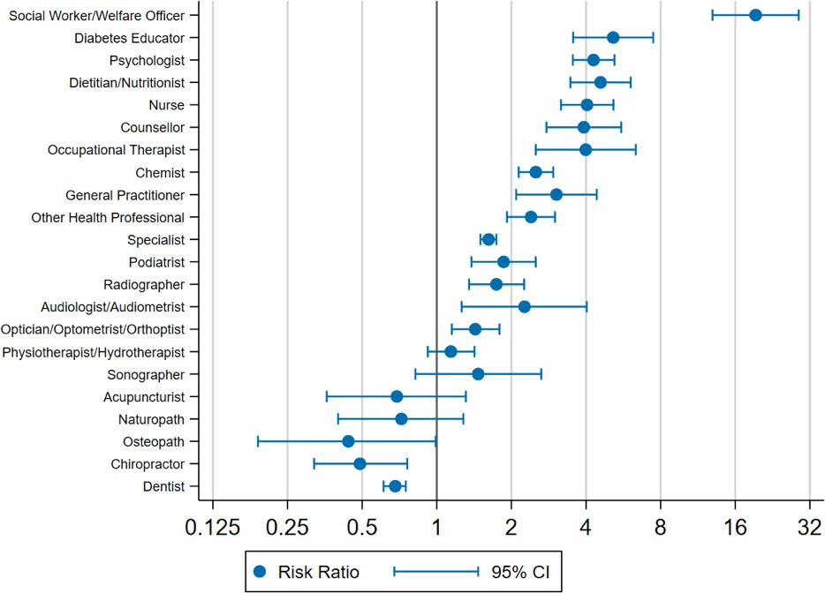

The same analysis was undertaken comparing the NSA group to wage earners Figure 8. This analysis demonstrates that:
- NSA recipients were significantly more likely to have seen 5 types of health professionals – social workers, psychologists, counsellors, nurses, and chemists.
- Similar to the finding in DSP recipients, the greatest difference between groups was observed for social worker/welfare officer where the NSA group were at more than
8 times greater risk of visiting a social worker in the past 12 months than wage earners.
- NSA recipients were at significantly lower risk of visiting a dentist, a chiropractor, an osteopath, or a physiotherapist in the preceding 12 months than wage earners.

Figure 8. Age and sex adjusted risk ratios for having visited a health professional at least once in past 12 months for NSA recipients compared to wage earners

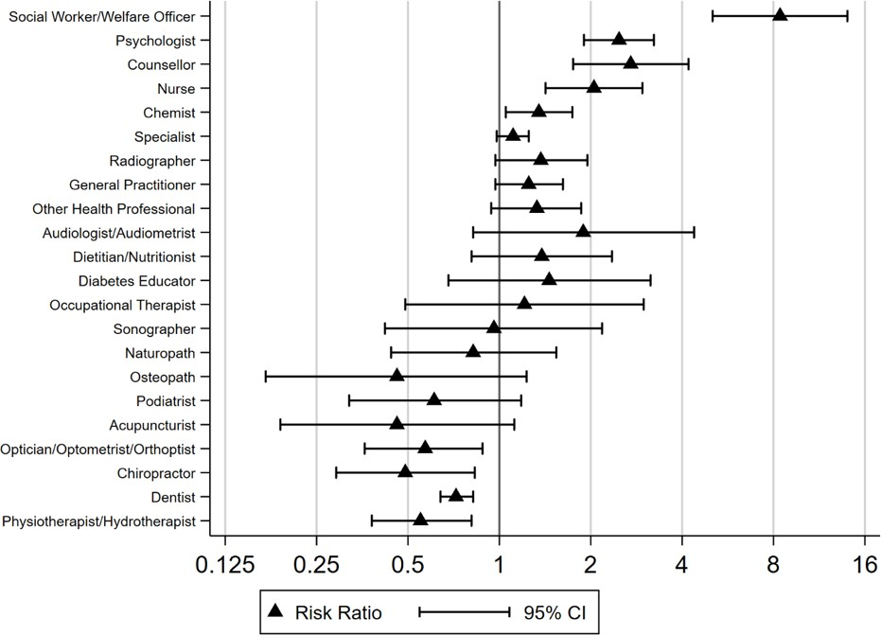

Visits to a Hospital
We also examined the prevalence of self-reported visits to a hospital or health centre and compared this between groups. The NHS collects information on admission as a hospital inpatient, visits to emergency, outpatient clinic or a day clinic in the preceding 12 month period.
The DSP group had the highest proportion of people reporting hospital visits across all four categories Table 6. In contrast wage earners had the lowest proportion of people reporting hospital visits across all categories.
Notably, more than one quarter (25.7%) of DSP recipients reported being admitted as a hospital inpatient in the previous 12 months and nearly one-quarter (23.3%) reported a visit to an emergency department.

TABLE 6. NUMBER AND PERCENTAGE OF INDIVIDUALS IN EACH GROUP WHO VISITED A
HOSPITAL OR HEALTH CENTRE IN THE PREVIOUS 12 MONTHS
Health Centre | Wage Earners Group | DSP Group | NSA Group
Hospital Inpatient | 826 (9.8%) | 164 (25.7%) | 69 (15.6%)
Emergency/Casualty | 872 (10.3%) | 148 (23.2%) | 69 (15.6%)
Outpatient Clinic | 567 (6.7%) | 146 (22.9%) | 56 (12.7%)
Day Clinic | 467 (5.5%) | 85 (13.3%) | 29 (6.6%)

Figure 9 shows the age and sex adjusted risk ratios of health centre visits in the preceding 12 months for DSP and NSA recipients compared to wage earners.
Results show that:
- DSP recipients were at 2 to 3 times the risk of visiting a hospital than wage earners, with the greatest risk being for visiting an outpatient clinic.
- NSA recipients were at 1.5 to 2 times increased risk than wage earners of visiting an outpatient clinic, being admitted as an inpatient and visiting an emergency department.

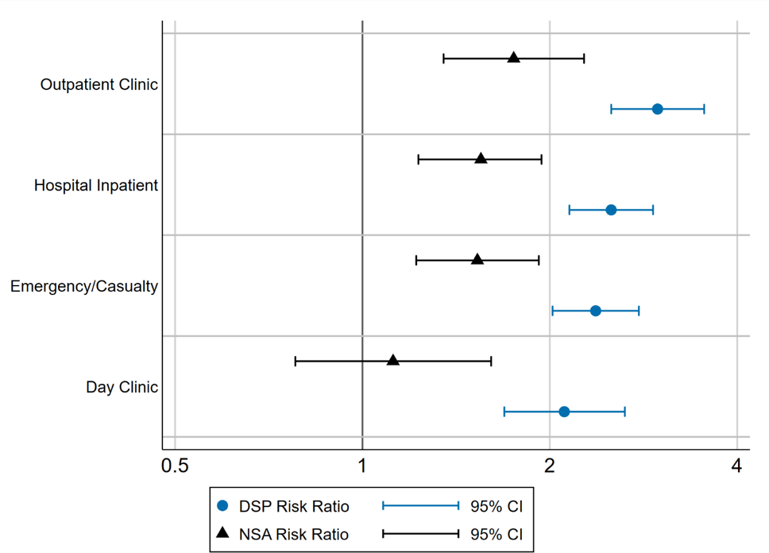
Figure 9. Age and sex adjusted risk ratios for having used a particular health service at least once in the past 12 months in DSP and NSA recipients compared to wage earners

Frequency of Health Service Use
We also examined the number of times people in each of the three groups reported visiting a health professional or a hospital in the preceding 12 months Table 7. Results indicate some substantial differences between groups including that:
- More than two in every five (42.6%) of DSP recipients visited a GP more than 10 times, compared to less than 5% of wage earners and 19% of NSA recipients.
- More than 10% of DSP recipients visited a specialist more than 10 times in the past 12 months, in comparison to 2% and 3% of the wage earners and NSA recipients, respectively.
- DSP recipients were substantially more likely to have had 2 or more hospital admissions, 2 or more visits to an emergency department and 2 or more visits to an outpatient or day clinic than the other groups.
- Although DSP recipients were the most likely group to not have visited a dentist in the past 12 months they were also the most likely to have visited more than five times.

TABLE 7. NUMBER AND PERCENTAGE OF INDIVIDUALS IN EACH GROUP WHO VISITED A
PARTICULAR HEALTH PROFESSIONAL OR HEALTH CENTRE BY FREQUENCY OF VISITS
Number of Visits | Wage Earners (N=8440) | DSP Group (N=638) | NSA Group (N=442)
General Practitioner
0 | 1340 (15.9%) | 27 (4.2%) | 51 (11.5%)
1 to 5 | 5721 (67.8%) | 205 (32.1%) | 227 (51.4%)
6 to 10 | 971 (11.5%) | 134 (21.0%) | 82 (18.6%)
11 or more | 408 (4.8%) | 272 (42.6%) | 82 (18.6%)
Dentist
0 | 4307 (51.0%) | 406 (63.6%) | 280 (63.3%)
1 to 5 | 3954 (46.8%) | 197 (30.9%) | 150 (33.9%)
6 or more | 179 (2.1%) | 35 (5.5%) | 12 (2.7%)
Specialist
0 | 5694 (67.5%) | 249 (39.0%) | 271 (61.3%)
1 to 5 | 2319 (27.5%) | 265 (41.5%) | 139 (31.4%)
6 to 10 | 276 (3.3%) | 55 (8.6%) | 19 (4.3%)
11 or more | 151 (1.8%) | 69 (10.8%) | 13 (2.9%)
Hospital Inpatient
0 | 7614 (90.2%) | 474 (74.3%) | 373 (84.4%)
1 | 642 (7.6%) | 98 (15.4%) | 42 (9.5%)
2 or more | 183 (2.2%) | 65 (10.2%) | 25 (5.7%)
Missing | 1 (< 1%) | 1 (0.2%) | 2 (0.5%)
Outpatient Clinic
0 | 7873 (93.3%) | 492 (77.1%) | 386 (87.3%)
1 | 295 (3.5%) | 40 (6.3%) | 24 (5.4%)
2 or more | 264 (3.1%) | 100 (15.7%) | 32 (7.2%)
Missing | 8 (0.1%) | 6 (0.9%) | 0 (0.0%)

TABLE 7. NUMBER AND PERCENTAGE OF INDIVIDUALS IN EACH GROUP WHO VISITED A
PARTICULAR HEALTH PROFESSIONAL OR HEALTH CENTRE BY FREQUENCY OF VISITS
Number of Visits | Wage Earners (N=8440) | DSP Group (N=638) | NSA Group (N=442)
Emergency/Casualty
0 | 7568 (89.7%) | 490 (76.8%) | 373 (84.4%)
1 | 644 (7.6%) | 67 (10.5%) | 42 (9.5%)
2 or more | 227 (2.7%) | 79 (12.4%) | 27 (6.1%)
Missing | 1 (< 1%) | 2 (0.3%) | 0 (0.0%)
Day Clinic
0 | 7973 (94.5%) | 553 (86.7%) | 413 (93.4%)
1 | 313 (3.7%) | 35 (5.5%) | 10 (2.3%)
2 or more | 152 (1.8%) | 47 (7.4%) | 19 (4.3%)
Missing | 2 (< 1%) | 3 (0.5%) | 0 (0.0%)

Age and sex adjusted incidence rate ratios were calculated to statistically compare the frequency of visits to healthcare professionals or hospitals.
This data is presented in Figure 10 and shows that:
- Both DSP and NSA groups had significant higher rate of visits to a GP or specialist than wage earners, with the DSP group having more than two times the rate of wage earners.
- Visits to a dentist were significantly less frequent in those receiving NSA than wage earners, but there was no evidence of a difference between DSP recipients and wage earners.
- People in the DSP group had over three times higher incidence than wage earners of hospital admission and four or more times higher incidence of visiting an outpatient clinic, emergency department of day clinic. A similar pattern was observed in NSA recipients though the differences from the wage earners group were less marked.

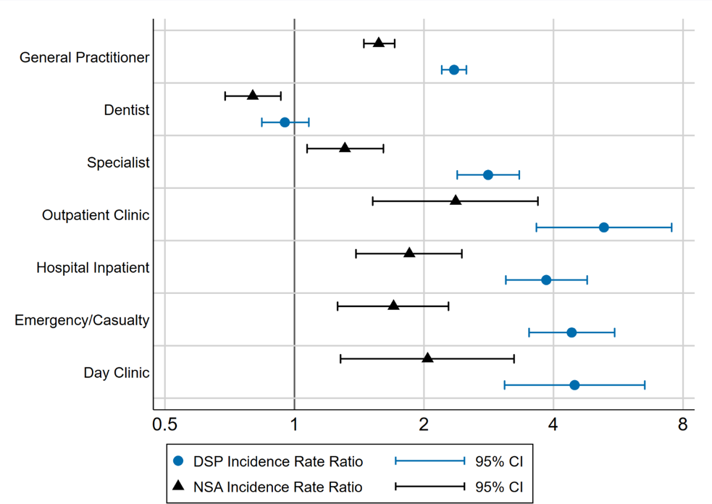
Figure 10. Age and sex adjusted incidence rate ratios for the frequency of visits to a health professional or hospital in the past 12 months for DSP and NSA recipients compared to wage earners

MEDICATION & SUPPLEMENT USE
Finally, we examined the use of medicines and supplements in the previous two weeks in the three study groups.
Eighty-six percent of DSP recipients had taken a medication in the previous two weeks, in comparison to 57% of NSA recipients and 46% of wage earners Table 8. In contrast, wage earners had the highest proportion of individuals who had taken a supplement in the past two weeks (43%), while in DSP recipients the proportion was slightly lower at 41% and in NSA recipients 36%.

TABLE 8. NUMBER AND PERCENTAGE OF INDIVIDUALS IN EACH GROUP WHO TOOK A
MEDICATION OR SUPPLEMENT IN THE PREVIOUS 2 WEEKS
Medications and Supplements | Wage Earners (N=8440) | DSP Group (N=638) | NSA Group (N=442)
Medications | 3879 (46.0%) | 551 (86.4%) | 252 (57.0%)
Supplements | 3592 (42.6%) | 261 (40.9%) | 159 (36.0%)

After age and sex adjustment, the risk of any medication use in DSP recipients was three times that for wage earners and slightly but significantly elevated for NSA recipients compared with wage earners Figure 11.
For supplement use the risk was in the opposite direction with both DSP recipients and NSA recipients having significantly lower risk of supplement use compared with wage earners.

Figure 11. Age and sex adjusted risk ratios for having taken at least one medication or supplement in the previous two weeks in DSP and NSA recipients compared to wage earners
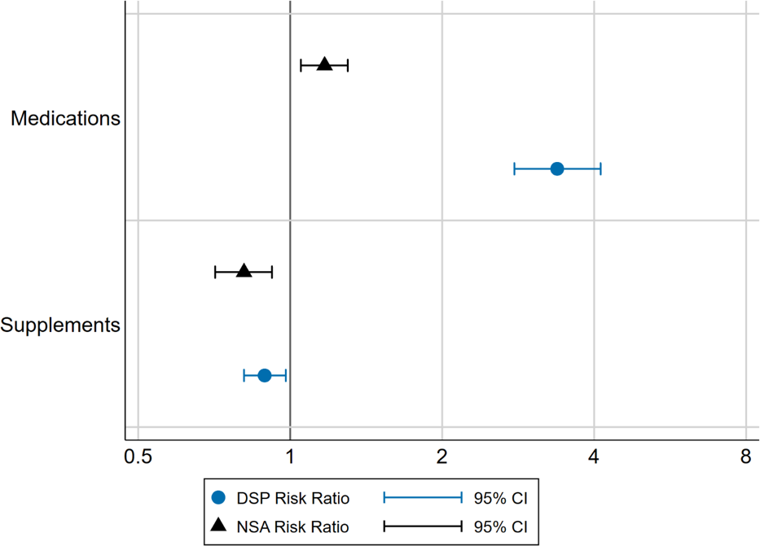

The NHS includes data on the number of medications or supplements taken in the past two weeks. We analysed this data to describe the prevalence of taking multiple medicines in the DSP and NSA groups. The number and percentage of each group reporting no use, one medicine or supplement, two to five, or six or more is presented in Table 9.
These results show that:
- Seventy-two percent of DSP recipients reported taking multiple medications and 28% reported taking more than five medications in the past two weeks.
- The proportion of NSA recipients and wage earners taking multiple medications was lower at 36% in NSA recipients and 23% among wage earners.
- The number of supplements taken was quite similar across all groups.

TABLE 9. NUMBER AND PERCENTAGE OF INDIVIDUALS IN EACH GROUP TAKING NONE, ONE OR
MULTIPLE MEDICINES OR SUPPLEMENTS IN THE PREVIOUS 2 WEEKS
Number of Medications and Supplements taken | Wage Earners (N=8440) | DSP Group (N=638) | NSA Group (N=442)
Medications
0 | 4561 (54.0%) | 87 (13.6%) | 190 (43.0%)
1 | 1978 (23.4%) | 90 (14.1%) | 93 (21.0%)
2 to 5 | 1773 (21.0%) | 281 (44.0%) | 132 (29.9%)
6 or more | 128 (1.5%) | 180 (28.2%) | 27 (6.1%)
Supplements
0 | 4848 (57.4%) | 377 (59.1%) | 283 (64.0%)
1 | 1692 (20.0%) | 122 (19.1%) | 76 (17.2%)
2 to 5 | 1785 (21.1%) | 131 (20.5%) | 74 (16.7%)
6 or more | 115 (1.4%) | 8 (1.3%) | 9 (2.0%)

Age and sex adjusted incidence rate ratios were calculated to statistically compare the number of different types of medications and supplements used.
This data is presented in Figure 12 and shows that:
- People in the DSP group reported three times the rate of using multiple medications than wage earners.
- The incidence rate for multiple medicine use was also significantly higher in NSA recipients compared with wage earners, though the effect is less pronounced than that for DSP recipients
- The incidence rate of supplement use in reference to wage earners was significantly lower in both DSP recipients and NSA recipients.

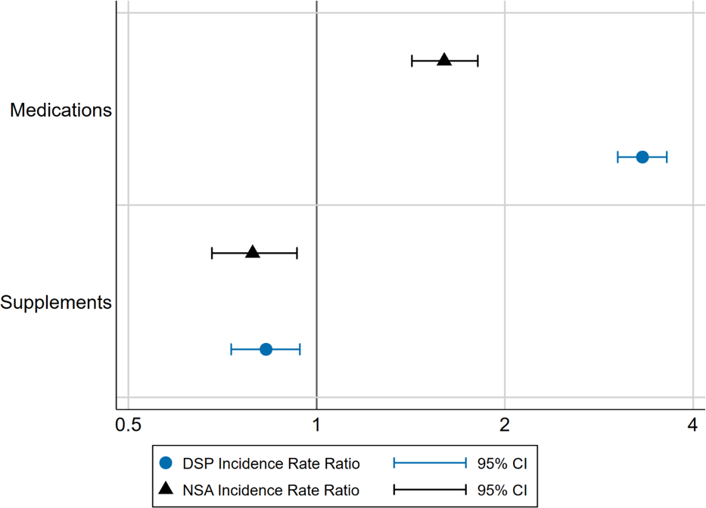
Figure 12. Age and sex adjusted incidence rate ratios for the number of different medications or supplements taken in the past two weeks for DSP and NSA recipients compared to wage earners

Types of Medicines Used
We also examined the different types of medicines used by people in each of the study groups. The NHS reports medicines in Anatomical Therapeutic Chemical (ATC) categories. The ATC categorisation is an international standard approach to classifying medicines.
Figure 13 reports the age and sex adjusted relative risk of reporting use of a medicine in each ATC category in DSP recipients compared with wage earners.
The results demonstrate that:
- DSP recipients had a significantly greater risk of having used a medication in the previous two weeks for 11 of 12 different ATC categories, in comparison to wage earners.
- The greatest risk was for dermatological drugs, nervous system drugs, and antineoplastic and immunomodulating agents, all of which had RRs of more than 3 in the DSP group compared with the wage earners group.

Figure 13. Age and sex adjusted risk ratios for having used a medication from an ATC category at least once in the past 2 weeks for DSP recipients compared to wage earners

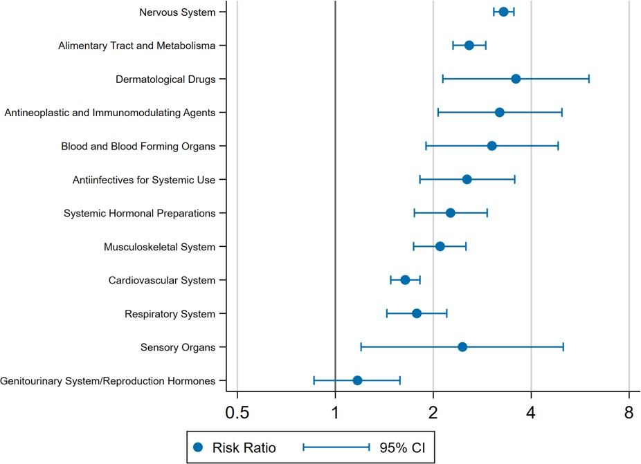

The same analysis was conducted comparing NSA recipients with wage earners and results are presented in Figure 14. These findings indicate that:
- NSA recipients had a greater risk of having used a medication in the previous two weeks for 4 different ATC categories and a decreases in risk for 1 ATC category, in comparison to wage earners.
- The largest increase in risk was for nervous system, musculoskeletal, and alimentary tract and metabolism medications. The decrease in risk was for genito-urinary system and reproductive hormones medications.

Figure 14. Age and sex adjusted risk ratios for having used a medication from an ATC category at least once in the past 2 weeks for NSA recipients compared to wage earners
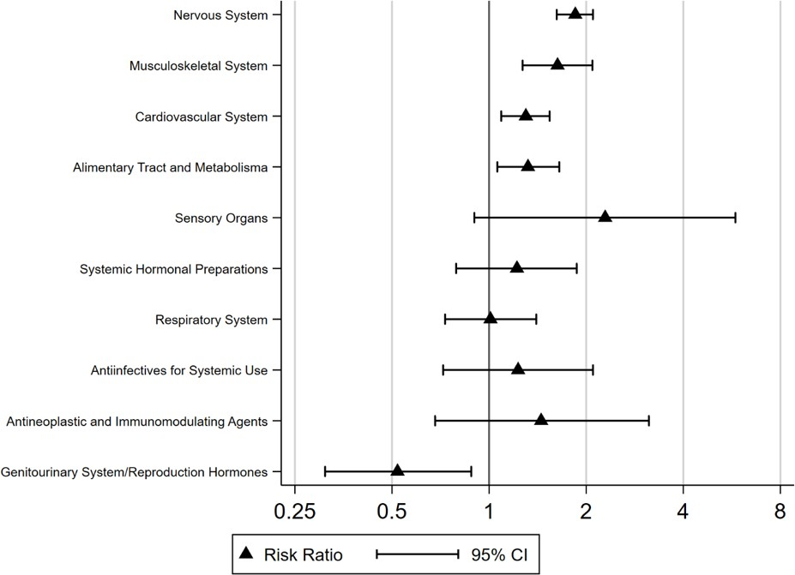

Strengths & Limitations
This study used self-reported National Health Survey data to examine the health conditions and health service use of people receiving DSP, NSA or earning wages. The study includes a large sample, including over 600 DSP recipients and more than 400 NSA recipients, and a particularly large reference group of wage earners (N=8440). This sample size enabled us to detect significant effects when the differences between groups were relatively small, noting that many of the group differences observed and reported here are large in nature. Availability of age and sex information allowed us to adjust estimates of risk and rate ratios to provide more accurate estimates of differences between groups, taking these important demographic features into account.
The NHS uses standardised international coding schema for health conditions (ICD-10) and for medicines (ATC) which enables comparison of observed results with other populations within Australia and internationally. Similarly the NHS collects detailed information on health conditions, health services and medicine use, which enabled us to drill down within broad categories and identify underlying features of conditions, service and medicine use. Finally, the NHS uses a standardised and well described approach to data collection, which has been used by the ABS over repeated iterations of the survey.
One limitation of the self-report methodology is that it requires respondents to recall use of services and to accurately report their health conditions. In the NHS, health service use data requires recall over the previous 12 months.
Individuals with a large number of conditions, medications and health service use may not be able to recall every health-related activity. Another limitation of self-reported data is that a reported condition may not have been diagnosed, and the NHS does not differentiate between diagnosed conditions and other conditions which the respondent may self-report.
There may also be a response bias in the sample of DSP and NSA recipients who participate in the NHS. People who are ill and disabled, or who do not have secure access to housing and communication technologies, may be less likely to participate in surveys. In addition, some groups of DSP and NSA recipients may be less able to participate due to restrictions in cognitive and intellectual function. This means that the sample of DSP and NSA recipients included in the NHS may not represent the entire population of DSP and
NSA recipients.
Our study focused on the 2014/15 iteration of the NHS and the data collected is cross-sectional. This means that all of the effects observed must be considered to be associations, and we cannot examine causal relationships or the temporal order of events, such as use of health services relative to the beginning of DSP benefit receipt or application. There have also been policy changes to the Australian benefit systems since 2014/15 that may have affected the health of DSP and NSA recipient and will not be captured by
this dataset.

Summary & Conclusions
This study found that people receiving Commonwealth government DSP benefits are at much greater risk of ill health than wage earners across a range of disease categories. This study demonstrates that DSP recipients are also more likely to assess their own health as being poor, report having multiple health conditions, and that the largest differences from people earning wages or business income are in the areas of mental and behavioural health. There are also many other conditions and diseases in which DSP recipients are at greater risk. Consistent with this increased health burden, DSP recipients are also heavy users of most healthcare services including primary care, allied health, community health, specialist medical and hospital services. In addition, DSP recipients are also much more likely to have multiple episodes of health service use than wage earners. Finally, this study demonstrates that the rate of medicine use and polypharmacy in DSP recipients is much higher than that in wage earners.
Similar to the DSP group, Australians receiving NSA benefits report an increased prevalence of disease in multiple categories, report poorer health, have a higher rate of multi-morbidity, are more likely to use some health services and be hospitalised, and have a higher rate of multiple episodes of health service use than wage earners. While the magnitude of these effects are not as large as those observed for DSP recipients, our findings confirm a significantly increased burden of ill health in Australian NSA recipients.
As with the DSP, the largest differences are in the domain of mental and behavioural health.
IMPLICATIONS
The differences in health status between Commonwealth benefit recipients and wage earners are stark, and demonstrate the substantial burden of disease and disability in both the DSP and NSA groups. Combined, more than
1.45 million Australians receive either the DSP or the NSA. Successive governments have introduced reforms to these working age benefits with the objective of restricting growth in expenditure and encouraging people off welfare benefits and into paid employment. These reforms have included, for instance, requiring most DSP applicants to demonstrate that they have
actively participated in job seeking or training for a period of 18 months before applying for the DSP, and changes to the provision of job finding and disability employment services.
Absent from these reforms has been consideration of the health of benefit recipients. Poor health is a barrier to work. There is substantial global evidence of the link between health and the ability to find and maintain work.[18] Peak Australian health practitioner bodies such as the Royal Australasian College of Physicians have released position statements summarizing this evidence and emphasising the health benefits of work.[19] It follows that actions to promote health in DSP and NSA recipients will support improvements in the ability of people receiving these benefits to participate in job finding and employment.

Our findings suggest there is substantial potential for improvement in health status of some people receiving DSP and NSA benefits. While many people receiving these benefits will be receiving appropriate treatment for their conditions and may have stable health, there is also evidence suggesting room for improvement. For example, while 69% of DSP recipients in this study reported a mental or behavioural problem, only 19% reported having seen a psychologist in the preceding 12-month period, 8% reported seeing a social worker and 7% a counsellor. This is suggestive of a large gap between health need and health service delivery, at least in the area of mental health.
There are multiple ways in which health can be improved. Health can be improved by delivering more targeted and more effective health services.
For example, it may be feasible to identify the individual health needs of DSP and NSA recipients at the point of entry to the welfare system, and then deliver targeted health services that address those needs. Such approaches are being trialed in other Australian benefit systems such as workers’ compensation.[20] We found that some health services that typically incur significant ‘out of pocket’ costs were less commonly used by DSP and NSA recipients than wage earners, including physical therapy and dentistry.
Improving access to these services may support improvements in health and reductions in disability.
Another opportunity for improved service delivery may be in the early identification of people with particularly complex or acute health needs,
or those at greater risk of hospitalization, which can then enable intervention to prevent health shocks. A simple extrapolation of the data from this study to a population level suggests that DSP recipients account for approximately 14% of all public hospital admissions among working age Australians
(15 to 65 years) [21], despite accounting for less than 5% of Australians in this age group. DSP recipients should be considered a group at high-risk of hospitalisation, warranting further attention and preventive action.
Health can be improved by addressing the social determinants of health. These are characterized by the World Health Organisation as the conditions in which we are born, grow, work, live and age.[22] They include things such as access to housing and nutrition, support services, social inclusion, education and training. Income poverty and financial stress are major barriers to achieving many of these things. There is evidence that life expectancy is inversely related to the generosity of welfare regimes [23], that poverty is a barrier to recovery from illness including mental illness [24] and that financial distress is associated with lower likelihood of returning to employment in people with significant health conditions.[25] Unemployed Australians and those not in the labour force (such as DSP recipients) are much more likely to be living in poverty than people employed full or part-time, with as many as 40% of working age people not in the labour force in poverty.[26] Actions that reduce the rate of poverty and financial stress amongst DSP and NSA recipients are thus likely to have a net positive impact on health.

Health, and particularly mental health, can also be improved by reducing the burden of engaging with government. The process of applying for welfare benefits and complying with obligations often required by benefit regimes can be stressful [27], has been linked with adverse impacts on the health of benefit recipients with illness and injury [28, 29] and a reduction in the ability to participate in employment.[30] People with cognitive, intellectual or psychological conditions and those with less education, smaller support networks or other vulnerabilities are more likely to be adversely affected.[27] Actions such as simplifying benefit application processes or funding services that can support people with disabilities to engage with Centrelink are likely to reduce these potentially adverse psychological impacts.
Future studies should examine the effectiveness of health service delivery to working age benefit recipients and the impact on health status and ability to engage in employment. There is a clear need for further research in this area to support policy development and service delivery. Longitudinal studies would provide particularly valuable information, and such studies may be feasible using administrative data (such as linked social security and MBS data) or a prospective cohort design. It will also be valuable to examine
sub-groups of DSP and NSA recipients to characterise groups with the greatest potential for improvement in health status. Such analyses may provide information to support the targeted delivery of services and supports to discrete groups, based on demographic, health or other characteristics.
In summary, the findings of this study when combined with prior evidence, suggest that an opportunity to improve the employment outcomes of people receiving the DSP and NSA is to focus on health improvement and disability reduction. Three avenues through which this may be achieved include better health service delivery, action on the social determinants of health,
and simplification of welfare processes. Such initiatives may be supported by coordinated action across government departments. There are examples of international policy initiatives in this field. For example, the UK government has created a cross-government Work and Health Unit that is jointly sponsored by the UK Department of Health and Department of Work and Pensions. The aim of the unit is to “improve the health and employment outcomes for disabled people and those with health conditions” including through the provision of healthcare to people with disability and work limitations. Similarly, Norway has a cross-government Directorate of Health and Social Affairs that operates under the joint auspices of the Ministry of Health and Care Services and the Ministry of Labour and Social Affairs.
In contrast, there appears to be little coordination between Australian social security and healthcare systems. Improving the coordination between health and welfare departments could reduce the burden to government while also improving the lives of Australians receiving disability support and unemployment benefits.

References
- Australian Government. Social Security Guide: 3.2.8.10 Mutual Obligation Requirements for NSA/YA Job Seekers Overview. Canberra, Australia 2019.
- DSS Demographics December 2018 [Internet]. 2018 [cited 10/04/2019]. Available from: https://www.data.gov.au/dataset/
- Department of Social Services. DSS Statistical Summary (June 2018). Canberra, Australia: Department of Social Services; 2018.
- Department of Social Services. Valuation Report 30 June 2015: Baseline Valuation. Canberra: Commonwealth of Australia, 2016.
- Department of Social Services. Labour market and related payments: A monthly profile (Feb 2019). Canberra: Australia: Department of Social Services; 2019.
- Parliamentary Budget Office. Disability Support Pension: Historical and projected trends Canberra: Parliament of Australia; 2018.
- Soldatic K, Fitts M. At what cost? Indigenous Australians’ experiences of applying for disability income support (Disability Support Pension). Penrith, New South Wales: Institute for Culture and Society, Western Sydney University; 2018.
- The Auditor General. Disability Support Pension — Follow-on Audit. Canberra: Australian National Audit Office; 2018 29 November 2018. Contract No.: Auditor-General Report No.13 2018–19
- Milner A, Page A, LaMontagne AD. Cause and effect in studies on unemployment, mental health and suicide: a meta-analytic and conceptual review. Psychological medicine. 2014;44(5):909-17.
- Roelfs DJ, Shor E, Davidson KW, Schwartz JE. Losing life and livelihood: a systematic review and meta-analysis of unemployment and all-cause mortality. Soc Sci Med. 2011;72(6):840-54.
- Butterworth P, Burgess PM, Whiteford H. Examining welfare receipt and mental disorders after a decade of reform and prosperity: analysis of the 2007 National Survey of Mental Health and Wellbeing. Aust N Z J Psychiatry. 2011;45(1):54-62.
- Kiely KM, Butterworth P. Social disadvantage and individual vulnerability: a longitudinal investigation of welfare receipt and mental health in Australia. Aust N Z J Psychiatry. 2013;47(7):654-66.
- Jensen NK, Bronnum-Hansen H, Andersen I, Thielen K, McAllister A, Burstrom B, et al. Too sick to work, too healthy to qualify: a cross-country analysis of the effect of changes to disability benefits. J Epidemiol Community Health. 2019.
- Barr B, Taylor-Robinson D, Stuckler D, Loopstra R, Reeves A, Whitehead M. ‘First, do no harm’: are disability assessments associated with adverse trends in mental health? A longitudinal ecological study. J Epidemiol Community Health. 2016;70(4):339-45.

- Shahidi FV, Ramraj C, Sod-Erdene O, Hildebrand V, Siddiqi A. The impact of social assistance programs on population health: a systematic review of research in high- income countries. BMC Public Health. 2019;19(1):2.
- Australian Bureau of Statistics. National Health Survey (2014-15), Expanded Confidentialised Unit Record File (CURF), Remote Access Data Laboratory (RADL). Findings based on use of ABS Microdata. In: Statistics ABo, editor. 2017.
- Australian Bureau of Statistics. 4363.0 - National Health Survey: Users’ Guide, 2014-15. Canberra, Australia; 2015.
- Waddell G, Burton AK. Is work good for your health and well-being? . London: The Stationery Office; 2006.
- Australasian Faculty of Occupational and Environmental Medicine. Australian and New Zealand Consensus Statement on the Health Benefits of Work: Position Statement - Realising the Health Benefits of Work. Canberra; Australia: Royal Australasian College of Physicians; 2011.
- Iles R, Long D, Ellis N, Collie A. Risk factor identification for delayed return to work: Best practice statement. Melbourne: Insurance Work and Health Group, Monash University; 2018 April 2018.
- Australian Institute of Health and Welfare. Admitted patient care 2014-15: Australian hospital statistics. . Canberra, Australia; 2018. Contract No.: Cat no HSE 172.
- CSDH. Closing the gap in a generation: Health equity through action on the social determinants of health. Final report of the Commission on the Social Determinants of Health. Geneva: World Health Organisation; 2008.
- Beckfield J, Bambra C. Shorter lives in stingier states: Social policy shortcomings help explain the US mortality disadvantage. Soc Sci Med. 2016;171:30-8.
- Weich S, Lewis G. Poverty, unemployment, and common mental disorders: population based cohort study. BMJ. 1998;317(7151):115-9.
- Ioannou L, Cameron PA, Gibson SJ, Ponsford J, Jennings PA, Georgiou-Karistianis N, et al. Financial and recovery worry one year after traumatic injury: A prognostic, registry- based cohort study. Injury. 2018;49(5):990-1000.
- Sila U, Dugain V. Income poverty of households in Australia: Evidence from the HILDA survey. . 2019 14 February 2019. Contract No.: T03443162.
- Herd P, Moynihan D. Administrative Burden: Policymaking by Other Means. Washington, USA: Russell Sage Foundation; 2019. 360 p.
- Kilgour E, Kosny A, McKenzie D, Collie A. Interactions between injured workers and insurers in workers’ compensation systems: a systematic review of qualitative research literature. J Occup Rehabil. 2015;25(1):160-81.
- Bartys S, Frederiksen P, Bendix T, Burton K. System influences on work disability due to low back pain: An international evidence synthesis. Health Policy. 2017;121(8):903-12.
- Collie A, Sheehan L, Lane TJ, Gray S, Grant G. Injured worker experiences of insurance claim processes and return to work: a national, cross-sectional study. BMC Public Health. 2019;19(1):927.

Appendix

TABLE 10. ABBREVIATIONS
ABS | Australian Bureau of Statistics
ATC | Anatomical Therapeutic Chemical Classification System
DSP | Disability Support Pension
ICD-10 | International Statistical Classification of Diseases and Related Health Problems – Version 10
NSA | Newstart Allowance
NHS | National Health Survey

